**Download/Sort/Convert/Preprocess/QC Raw Data**

**Required Software**: Filezilla (or another FTP software), Horos, Matlab, MRIcoGL

1. **Download raw data from CBIHome**
   1. Access CBIHome through an FTP client (requires MUSC wifi or VPN)
      1. sftp://cbihome.musc.edu
      2. Log in with NETID and PW
   2. Navigate to MRdata folder

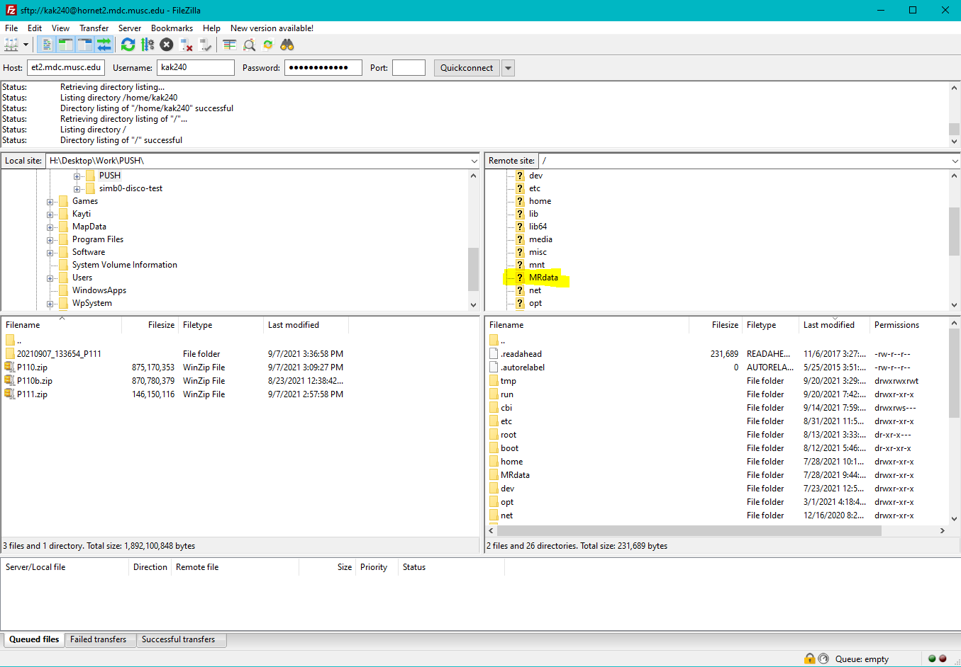

* 1. Navigate to the folder of the PI of the study, then to the study folder, then click on the ‘upload’ folder
  2. You will see a series of .zip folders, download whichever you need.

1. **Raw data QCing**
   1. Unzip the .zip dicom folder
   2. Open Horos and drag the entire unzipped dicom folder into the program
      1. Select ‘copy the links’
   3. **Scroll through scans**
2. **Sort and convert raw dicoms**
   1. Sort dicoms
      1. Note: there are other ways of sorting such as:
         1. [**https://github.com/TheJaeger/dicomSort**](https://github.com/TheJaeger/dicomSort)
         2. [**https://github.com/kaytiii/pycomsort**](https://github.com/kaytiii/pycomsort)
   2. Convert raw data from dicom to nifty using dcm2niix
      1. There are many ways to name converted files using dcm2niix flags
         1. Using the flags –f %p is a good standard way of converting with comprehensible file names
3. Initial data processing
   1. Depending on the study goals, it may be necessary to perform some type of processing shortly after scans are acquired
   2. For studies using diffusion data, artifact correction and parametric map calculation is required
      1. PyDesigner is an in-house software used to do both of these tasks ( see Image Analysis 101)
   3. Other processing may be required, such as T1 segmentation with Freesurfer, though this varies by study.